**ReactJS Project Solutions**

**Problem Statement:** Build a Front End Application that uses Unsplash API to retrieve images from it and display 12 of them to user based on what they searched for

**The requirements look like this:**

1. Get an Unsplash API Client Key by signing up for a free account (alternatively you can use flickr or other image provider API)

2. A user should be able to search for images by using a search box and a button

3. If no image is found the APP should show no mage found

4. If images are returned, then display their small dimension (links will be in the result returned)

5. Each image being shown should also link to higher resolution version of the image itself

6. When the image data is being loaded from the api you should show a loading indicator (e.g. spinner or text that says loading etc.)

7. If there is an error in the API log it to the console

8. Make sure to use routes, context and hook.

9. Make sure to format data returned from the API in JSON if using fetch function to get data

***Solutions:***

Step1: Created a create application by running below command on terminal.

npx create-react-app search-images-app

Step2: Write below code in App.js

**App.js**

import Search from './components/search/Search.js';

function App() {

  return (

    <div className="App">

      <Search />

    </div>

  );

}

export default App;

Step2.2: Create a folder components, inside this folder make another folder Saerch.js.

Write below code in Search.js

**Search.js**

import React, {useState} from 'react';

import './Search.css';

function Search() {

  const [value, setValue] = useState("")

  return (

      <div>

          <div className="mydiv">

            <span>Search here</span>

            <input

            type="text"

            value={value}

            onChange={(e) => setValue(e.target.value)} />

            <button>Get Images</button>

          </div>

      </div>

  );

}

export default Search;

Step2.3: Write below code in Search.css

**Search.css**

.App {

  text-align: center;

}

span{

  color:blue;

  font-size:large;

  margin-top: 5px;

}

.mydiv{

  display: flex;

  justify-content: space-around;

  margin: 30px 30%;

  box-shadow: 1px 1px 5px grey;

  padding: 10px;

  border-radius: 25px;

}

input{

  width: 40%;

  border-radius: 15px;

}

button{

  background-color: #4CAF50; /* Green */

  border: none;

  color: white;

  padding: 10px 25px;

  text-align: center;

  border-radius: 20px;

  font-size: large;

}

Step3.1: To run this application, type below command on terminal.

npm run start

Step3.2: By running above command, our application will be look as shown below.

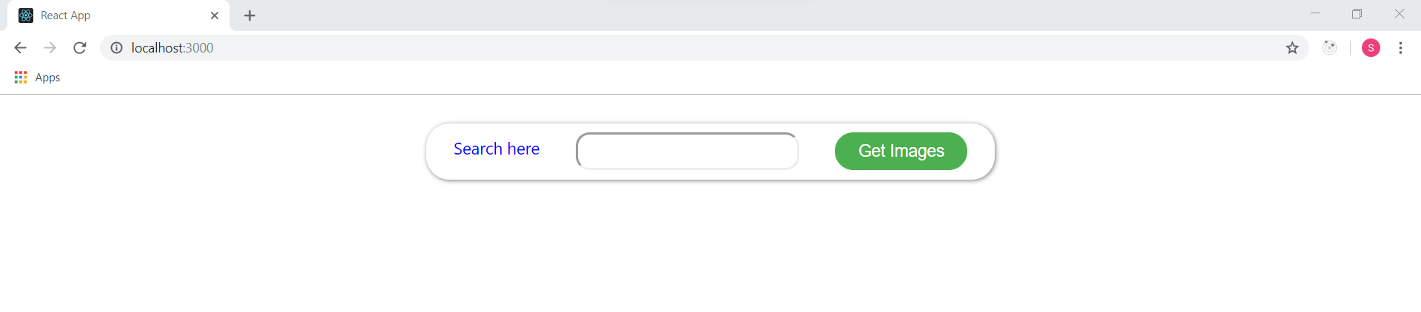

Step4: Get an Unsplash API Client Key by signing up for a free account.

Copy Access key and paste in client_id

 client_id query parameter:

<https://api.unsplash.com/photos/?client_id=YOUR_ACCESS_KEY>

Step5.1: To get Images from Unsplash API, add below code snippets in Search.js

*const[results, setResults] = useState([])*

*//creating function*

*const fetchImages = () =>{*

*fetch(`https://api.unsplash.com/search/photos?client_id=zcBWarnQ_Q7liF4EFTu2_Zz5SoqwIKjhHzVxHVSSxuk&query=${value}&orientation=squarish`)*

*.then(res=>res.json())*

*.then(data=>{*

*//console.log(data)*

*setResults(data.results)*

*})*

*}*

*<button onClick={()=>fetchImages()}>Get Images</button>*

*<div className="gallery">*

*{*

*results.map((item)=>{*

*return <img className="item" key={item.id} src={item.urls.regular}></img>*

*})*

*}*

*</div>*

Now Search.js code will be

import React, {useState} from 'react';

import './Search.css';

function Search() {

  const [value, setValue] = useState("")

  const[results, setResults] = useState([])

  //creating function

  const fetchImages = () =>{

    fetch(`https://api.unsplash.com/search/photos?client_id=zcBWarnQ_Q7liF4EFTu2_Zz5SoqwIKjhHzVxHVSSxuk&query=${value}&orientation=squarish`)

    .then(res=>res.json())

    .then(data=>{

      //console.log(data)

      setResults(data.results)

    })

  }

  return (

      <div>

          <div className="mydiv">

            <span>Search here</span>

            <input

            type="text"

            value={value}

            onChange={(e) => setValue(e.target.value)} />

            <button onClick={()=>fetchImages()}>Get Images</button>

          </div>

          <div className="gallery">

            {

              results.map((item)=>{

                  return <img className="item" key={item.id} src={item.urls.regular}></img>

              })

            }

          </div>

      </div>

  );

}

export default Search;

Step5.2: Add some more css styling in Search.css

.gallery{

  display: flex;

  flex-wrap: wrap;

  justify-content: space-around;

}

.item{

  width:20%;

  height: 20%;

  margin: 5px;

}

Step6: When we type flower and click on Get I mages button, then it will shows images.

